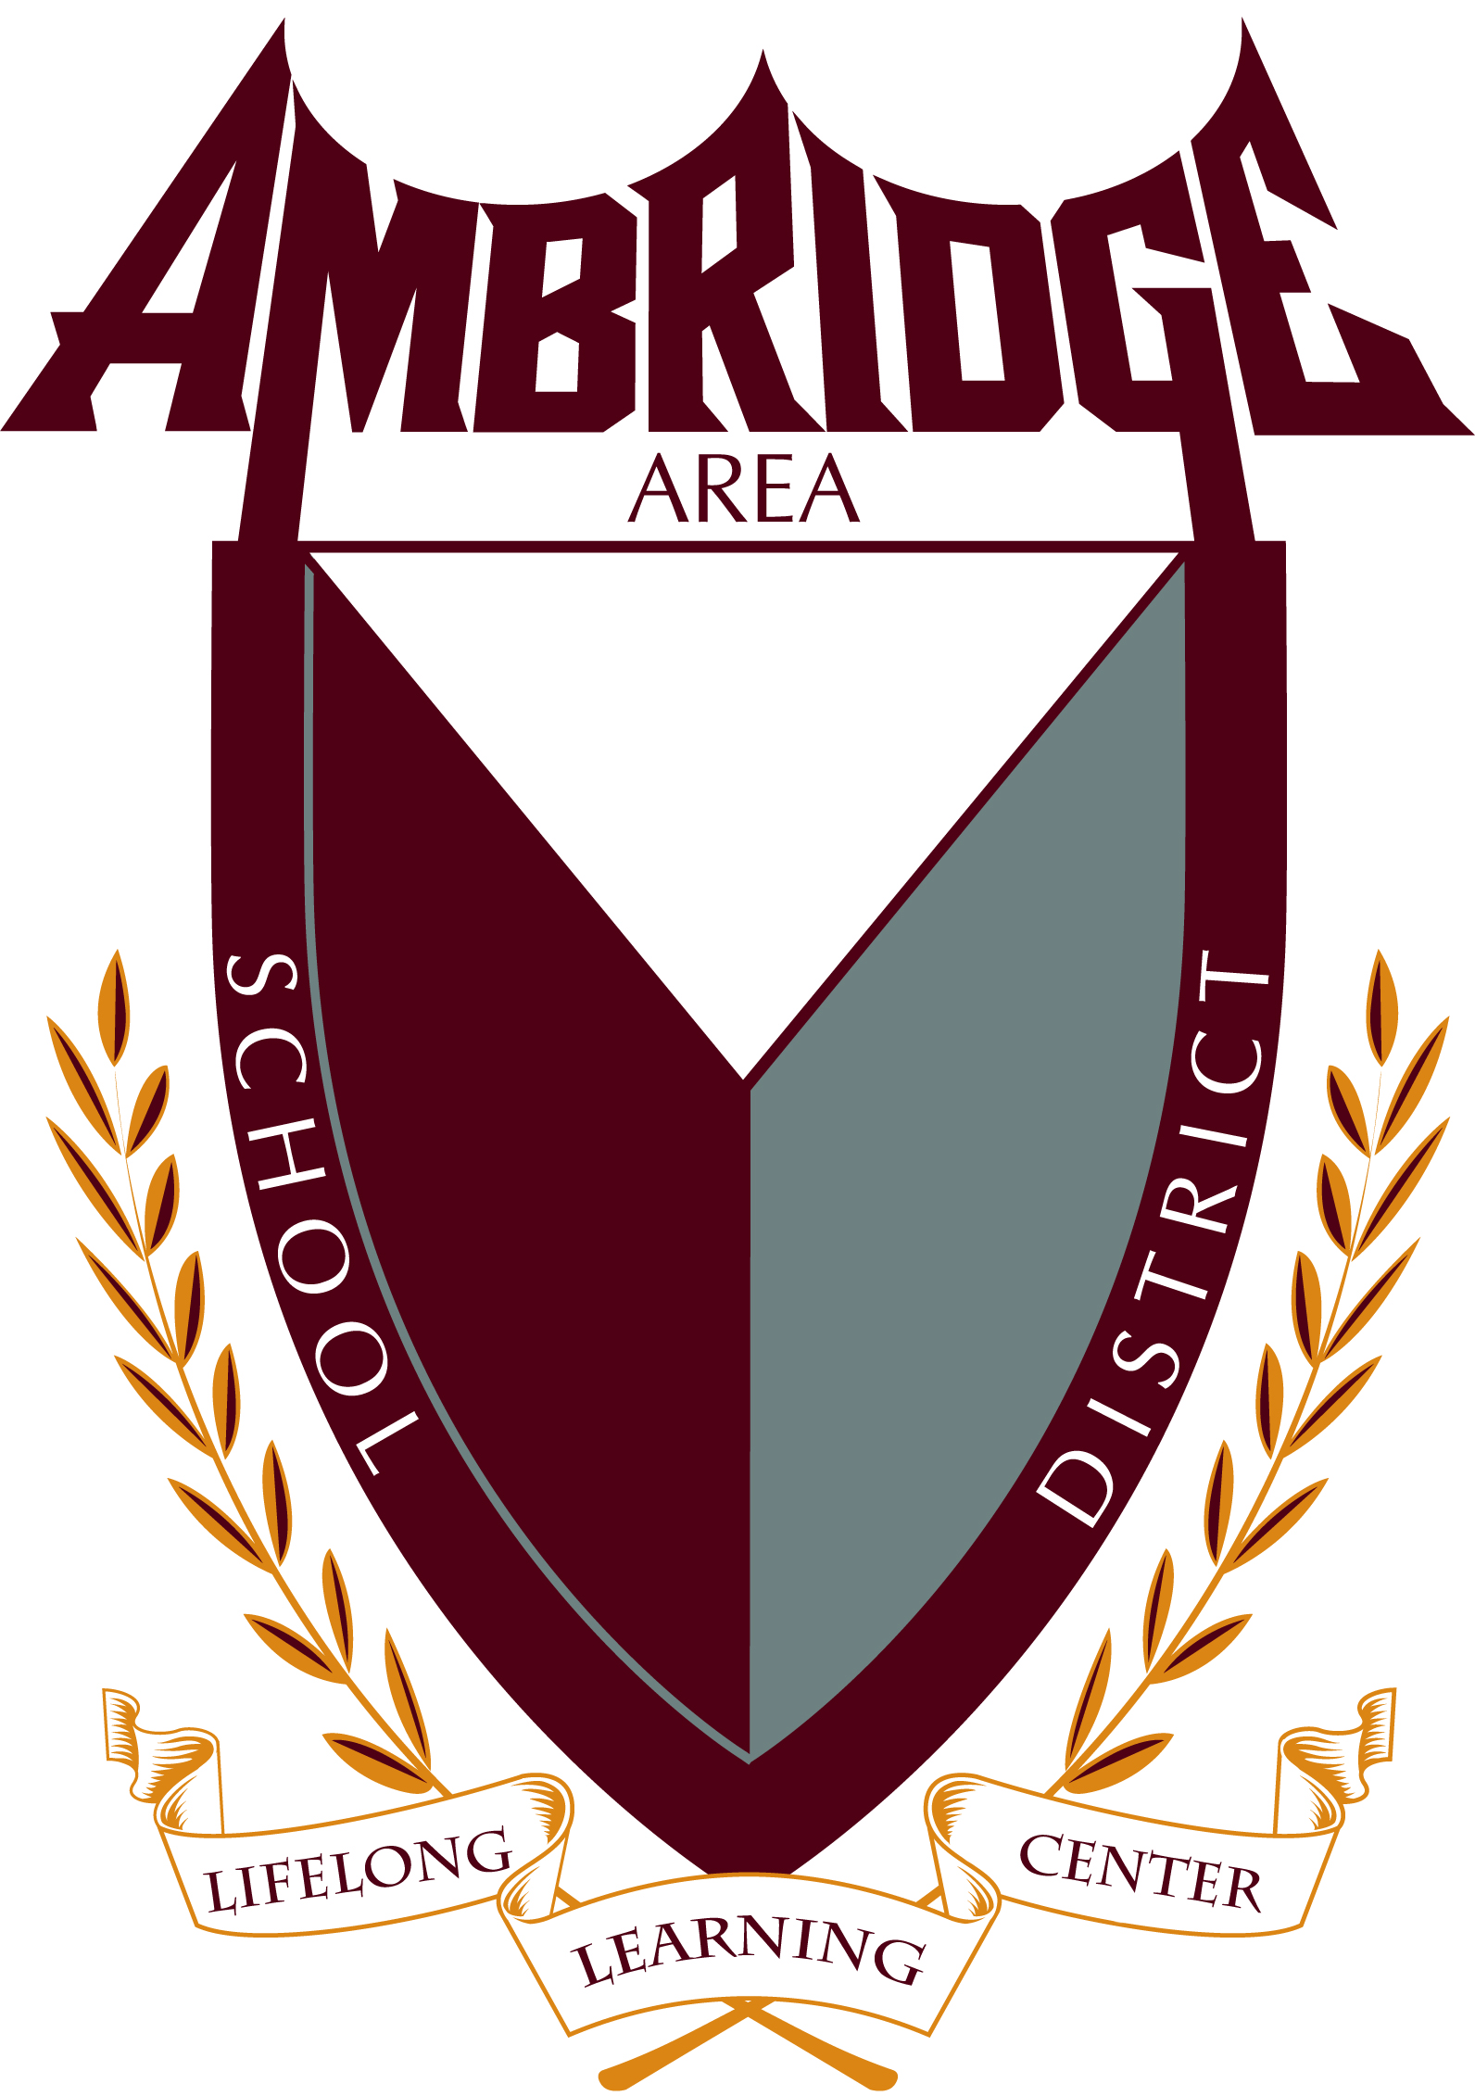
AMBRIDGE SCHOOL DISTRICT FOOD SERVICE STUDENT SCHOLARSHIP
Each year, the Ambridge Area School District Food Service Department offers a scholarship to a graduating senior, who is furthering his/her education in the field of “Special Education”. The Alyssa McKee Memorial Scholarship is a $500.00 scholarship in memory of a 2012 graduate who was majoring in Special Education.
This scholarship will be provided through the Ambridge Area Food Service Department. Alyssa’s grandmother, Mrs. Sharon McKee, is a retired head cook of both the Ambridge Junior High and Senior High. She had served the district’s food service department and interacted with thousands of students serving nutritious meals with loving-kindness for over twenty years.
To qualify, an applicant must:
- Be a graduating senior, entering an institution of higher education, majoring in a special education-related field.
- Be a student in good-standing, with at least a 3.0 grade point average.
- Submit an official transcript of high school grades.
- Submit a typed essay, 650 words or less, in a paragraph form explaining your interest in the Special Education field, and your primary educational and lifetime goals.
- Submit two letters of recommendation—one from an Ambridge faculty member and the other letter from a person of the student’s choice. Both of these should include information covering the following:

- Capacity in which the applicant is known
- Length of time applicant has been known
- Personality
- Initiative
- Leadership qualities
- Integrity
- Professional potential

Failure to complete the above requirements will result in a disqualification. The Scholarship recipient will be announced at the Academic Awards Banquet.

Return the completed application, essay, proof of a 3.0 grade point average or better, official transcript, and letters of recommendation postmarked by Monday, April 27, 2021 to:

Mrs. Janet Gaffney
Food Service Director
Ambridge Area School District
909 Duss Avenue
Ambridge, PA 15003

