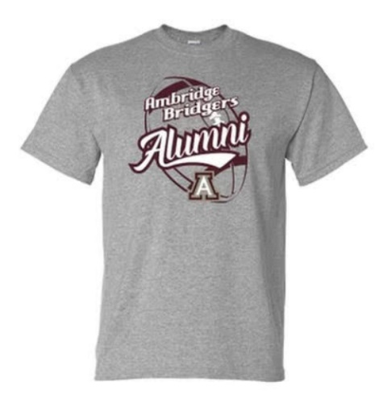
Ambridge Area School District
Alumni Football Game – September 17, 2021

Name: _________________________________ Phone Number: ______________________________
Address: _______________________________________ Email: _______________________________________
Shirt Options | Payment Options | Ordering Options
Youth Short Sleeve ($7.00)  ___ Youth Small  ___ Youth Medium  ___ Youth Large  Adult Short Sleeve ($12.00)  ___ Adult Small  ___ Adult Medium  ___ Adult Large  ___ Adult XL  ___ Adult 2XL + $2.00  ___ Adult 3XL + $2.00  ___ Adult 4XL + $2.00  Long Sleeve ($15.00)  ___ Adult Small  ___ Adult Medium  ___ Adult Large  ___ Adult XL  ___ Adult 2XL + $2.00  ___ Adult 3XL + $2.00  ___ Adult 4XL + $2.00  Hoodie ($25.00)  ___ Adult Small  ___ Adult Medium  ___ Adult Large  ___ Adult XL  ___ Adult 2XL + $2.00  ___ Adult 3XL + $2.00  ___ Adult 4XL + $2.00 | Option 1: Cash and Checks can be mailed to Jenn Phillips with order form to 901 Duss Avenue, Ambridge, PA 15003.  Checks can be made out to Ambridge Cheer and Football Boosters.  Option 2: Payments can be made through Venmo @AmbridgeCheer-Boosters  Please write your first and last name in the subject line. | Option 1: Mail payment and form.  Option 2: Order online at https://forms.gle/e5E47Wj81A1yZQLG7
 |  | Pick Up Options
Option 1: Wednesday, September 15 at the high school from 3-6PM.

Option 2: Friday, September 17 at the Alumni Football Game.

If you have any questions, please contact Jenn Phillips at jphillips@ambridge.k12.pa.us.

TOTAL AMOUNT ATTACHED: _________

